CHAPTER 3 : LAB EXPERIENCE REPORT

CST620-msg.txt and CST620-original-msg.txt files matched and encryption and decryption options are found on the file option of Kleopatra software. Also, CST620-msg-dsg.txt and CST620-original-msg-dsg.txt files matched and Kleopatra was utilized to sign the message, which ensures data integrity, authentication, and non-repudiation. Whenever a wrong certificate or key is utilized to decrypt and encrypt an error message pops up that inhibit accessibility. Whenever a message is tampered with, the encryption and decryption processes will generate an error code inhibiting accessibility based on initial passwords. Whenever message is tampered during transit, its accessibility is limited and encryption will generate errors.

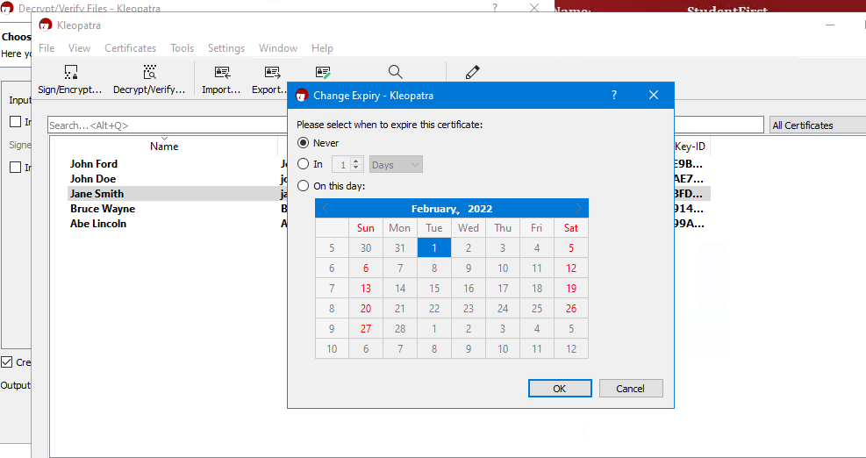

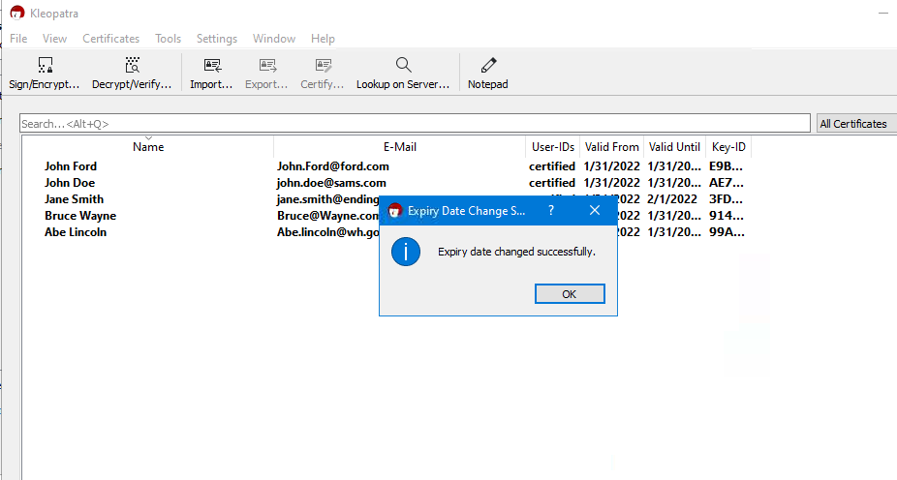

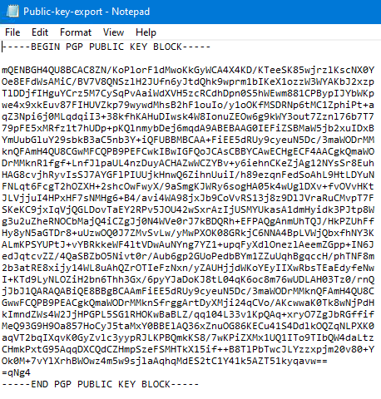

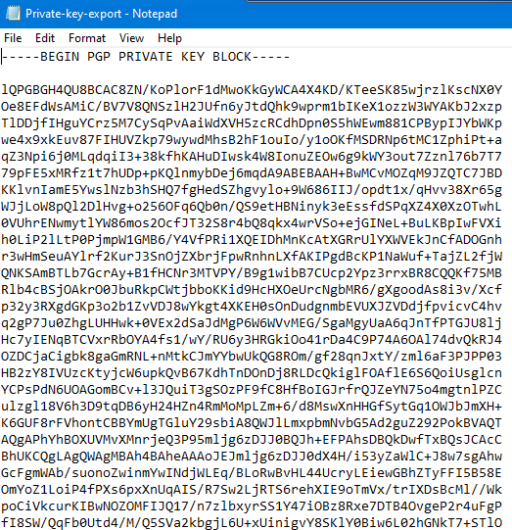

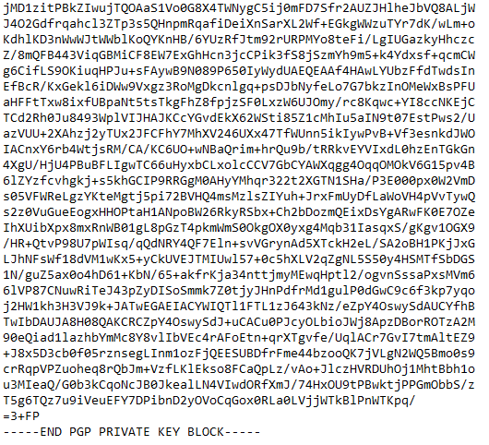

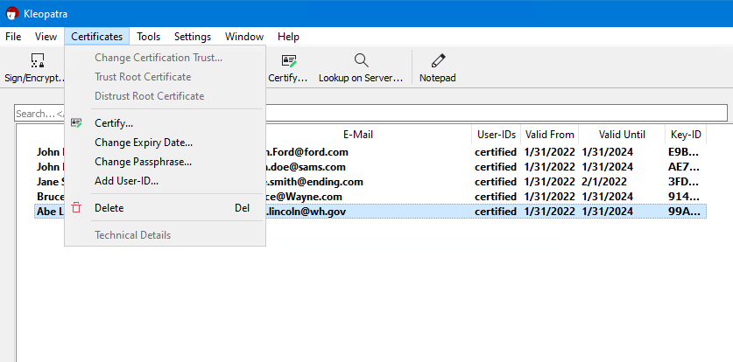

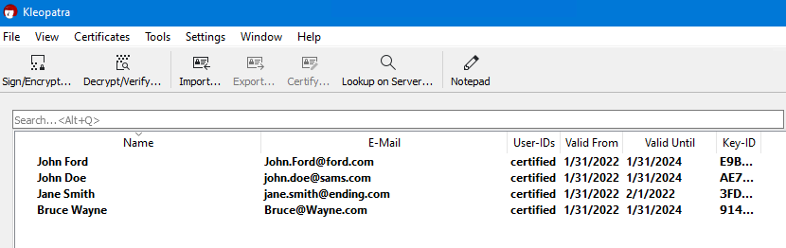

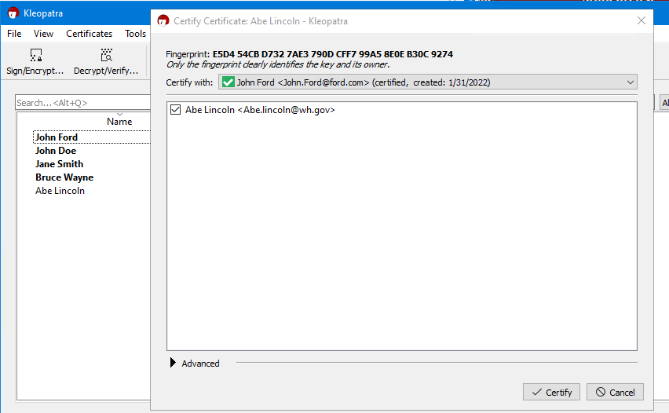

Expiry date for certificate are important since they demonstrate the validity of the keys and certificates. Whenever wrong passcodes are used access to the message becomes limited. It is essential to regularly change passphrase to ensure high level of security for the stored data or information. The management of pair key depends on encryption and decryption of the data. The management of certificate relies on expiry date and passcode update and management.

## ***Crypt Tool***

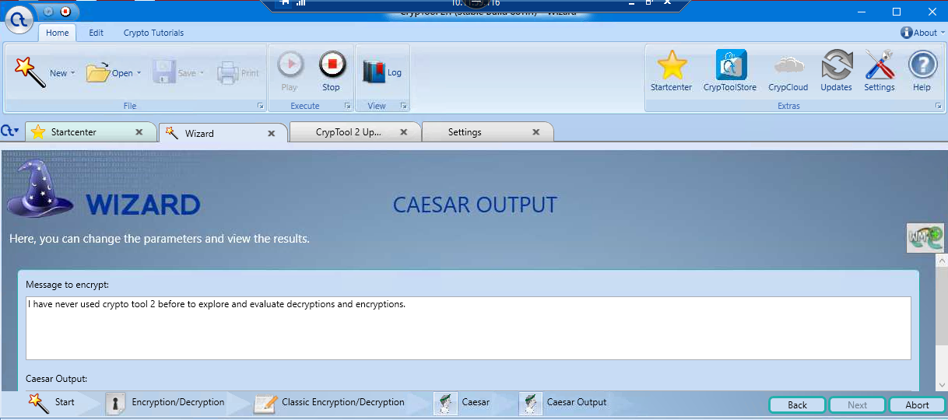

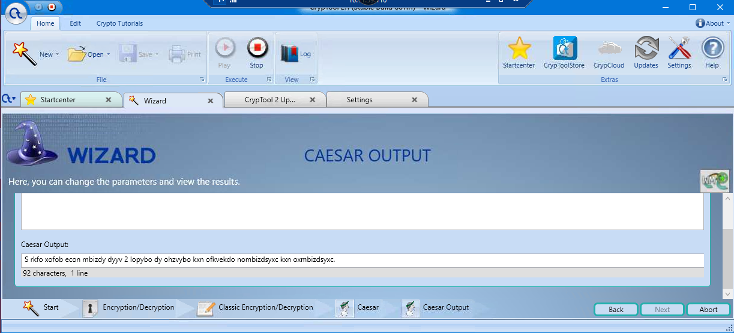

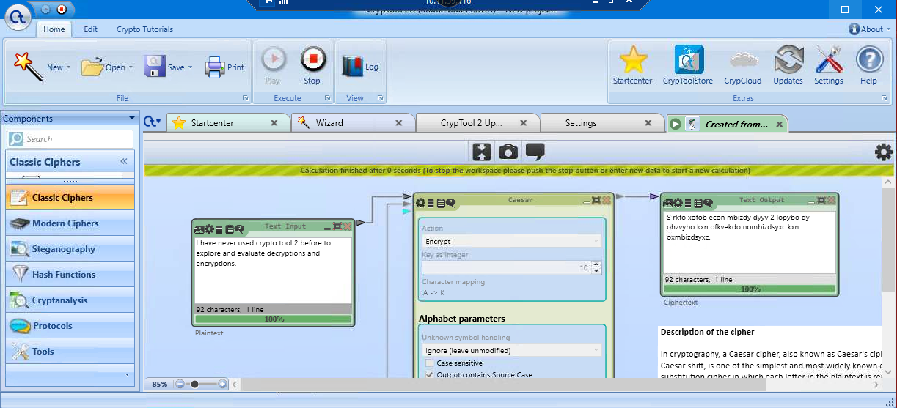

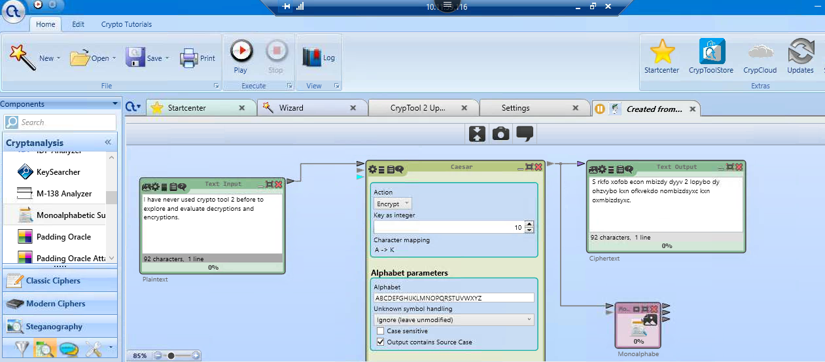

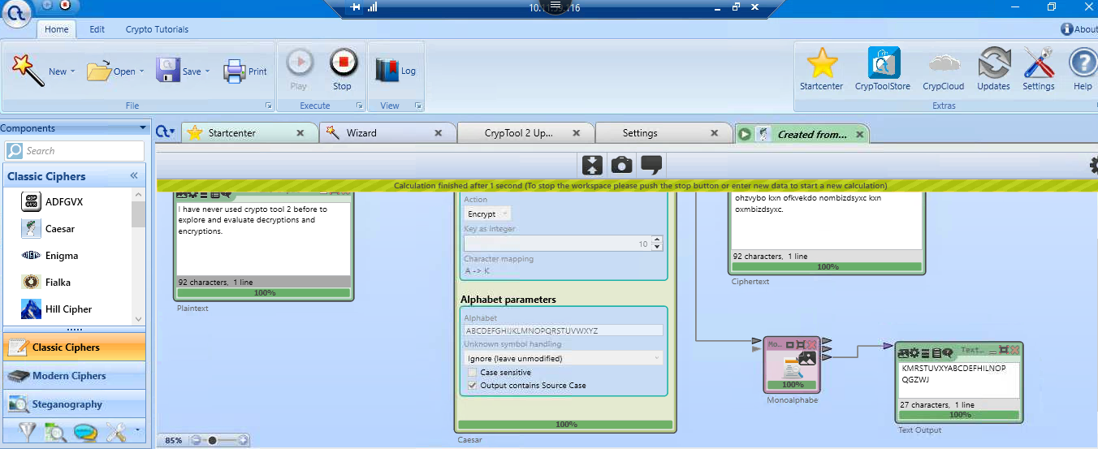

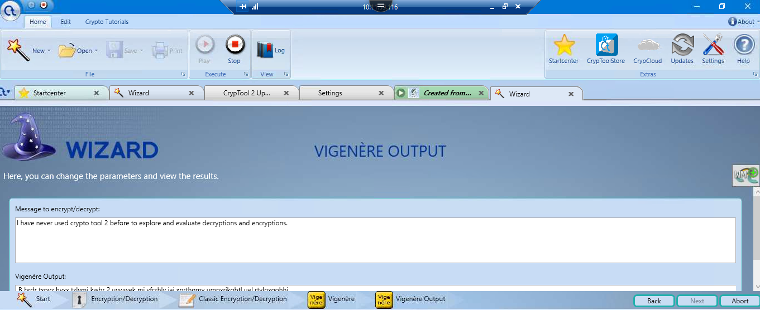

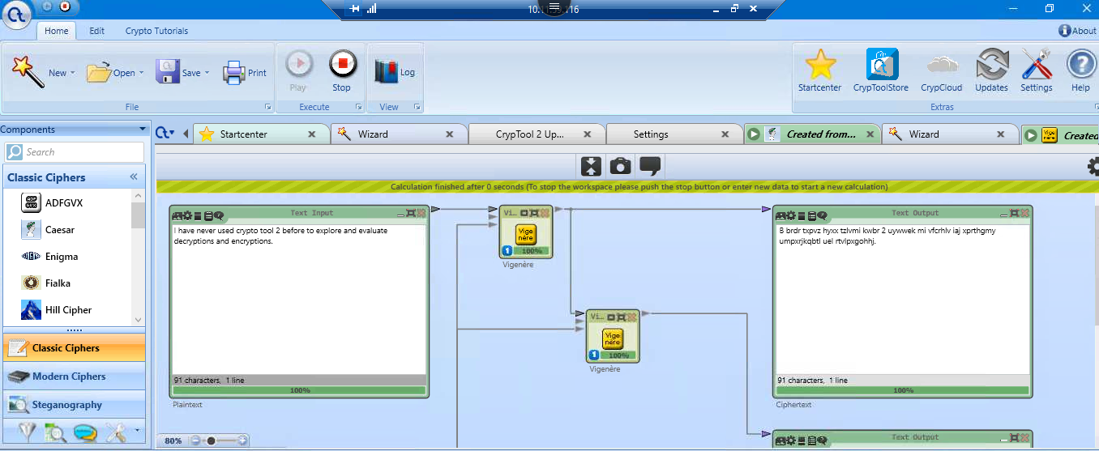

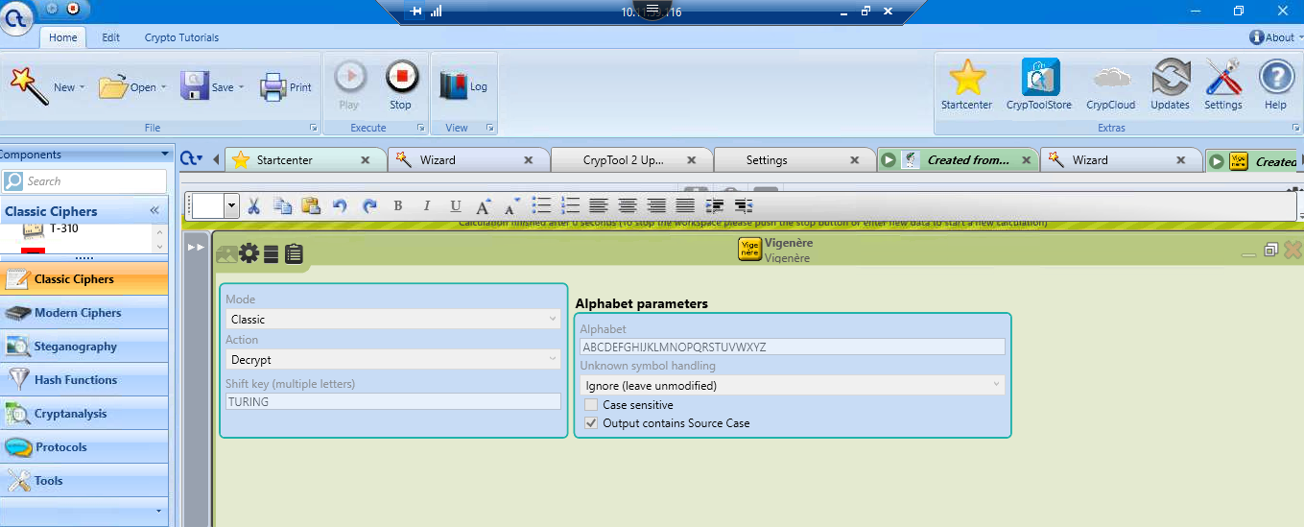

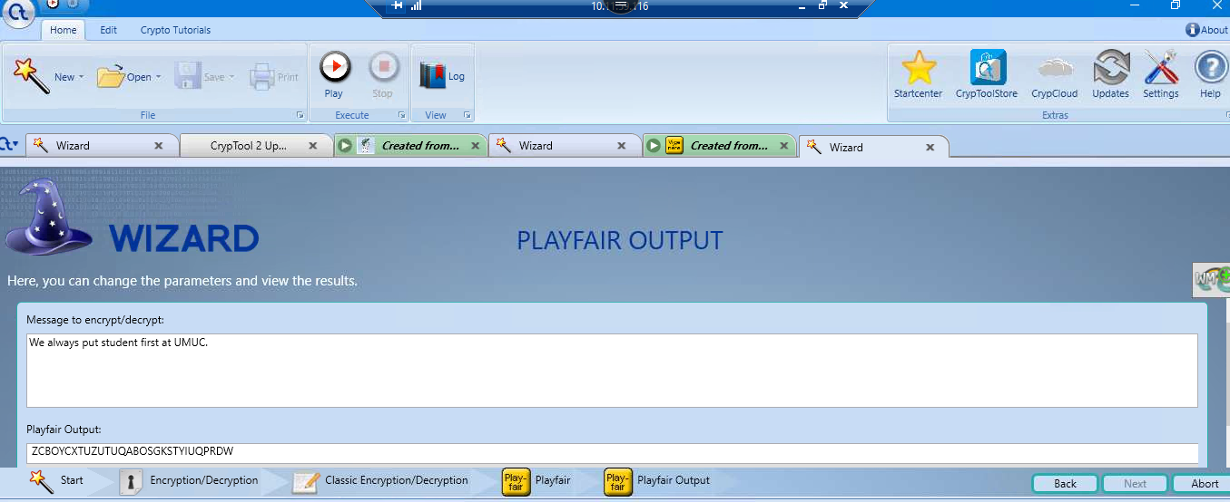

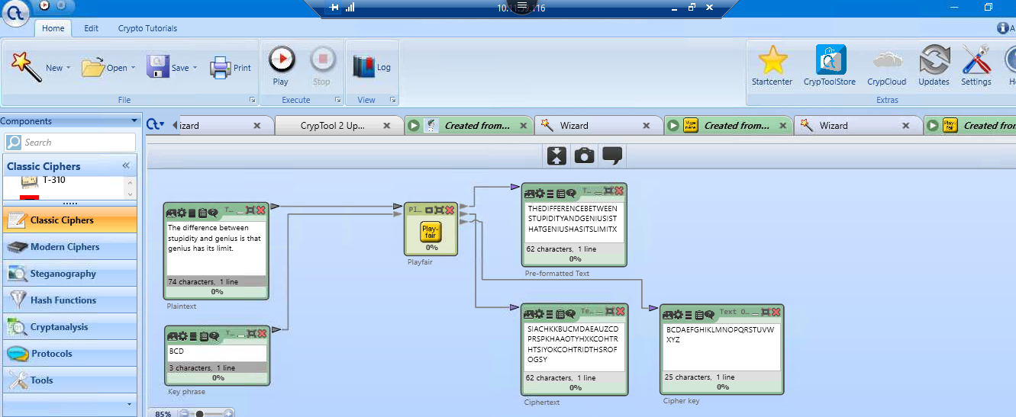

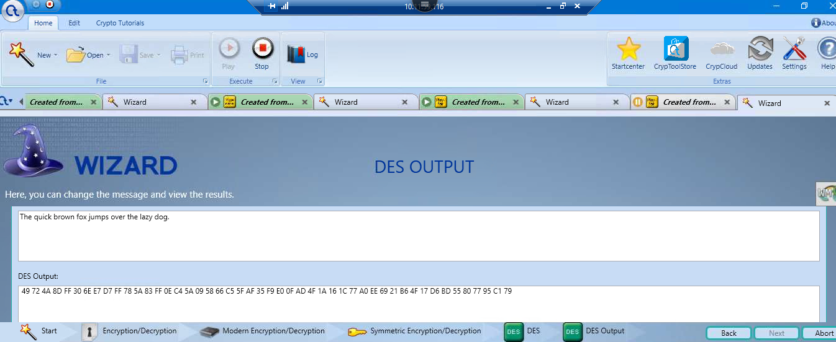

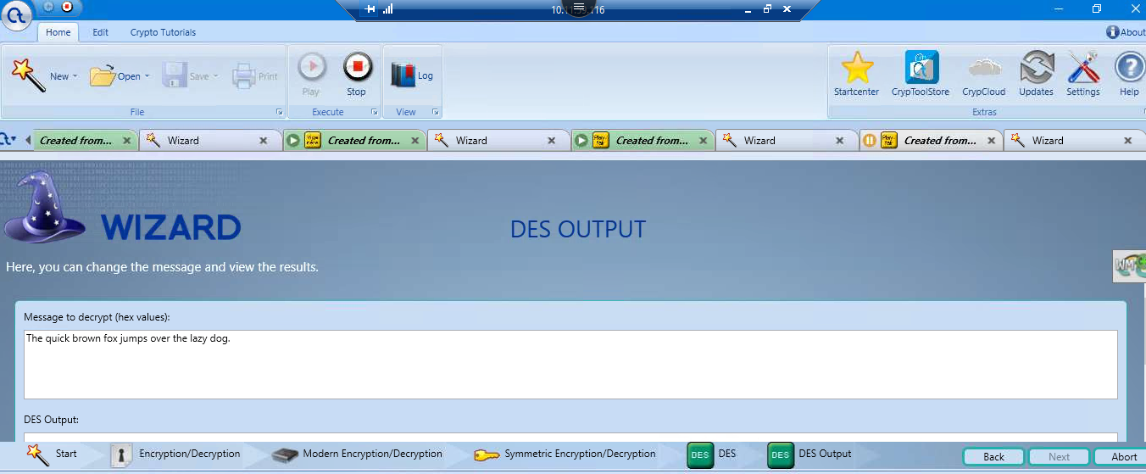

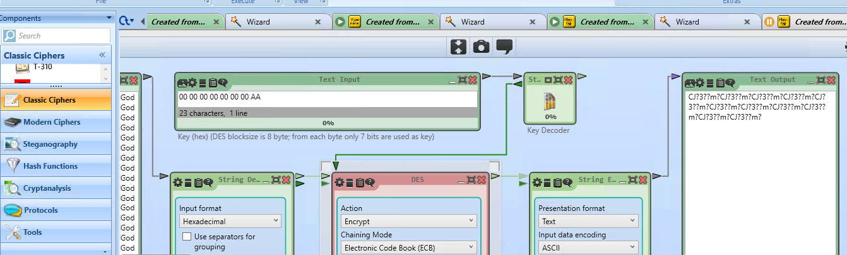

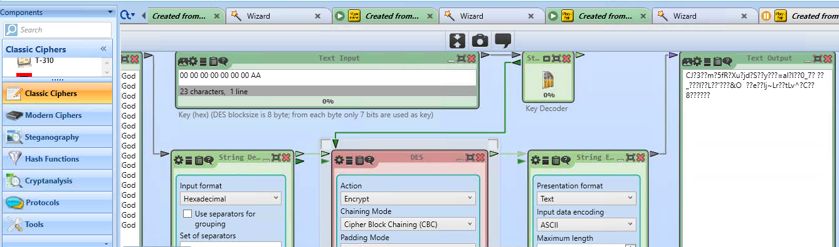

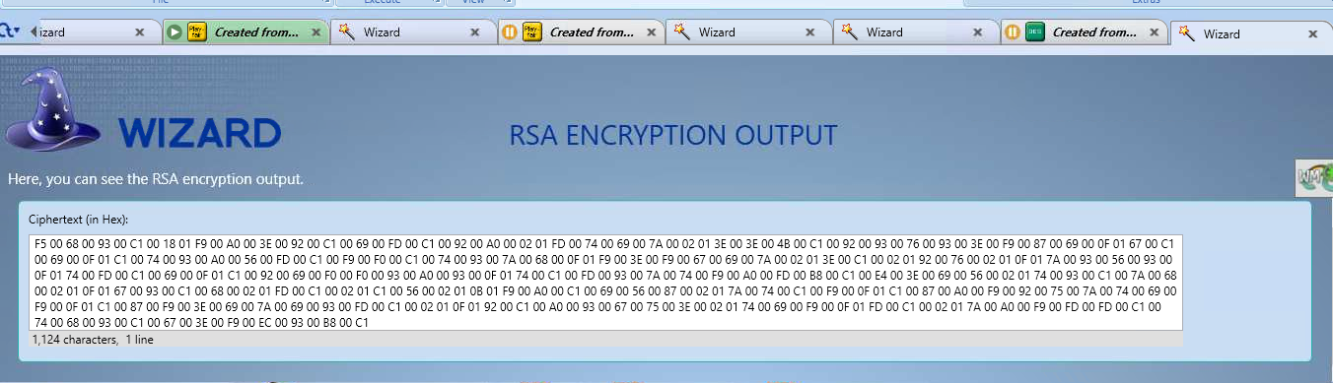

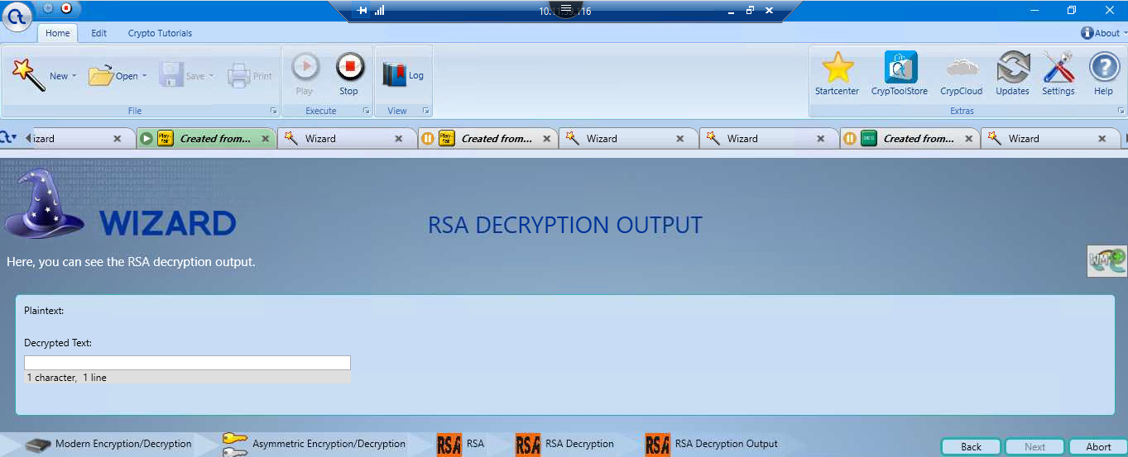

**Conclusion**

As security breaches in the healthcare industry continue to rise, enterprise key management is necessary and mandatory for hospitals and businesses to protect their data and information. As a result, many organizations have shifted their security efforts to data encryption. The PKI application is the most important and versatile in the enterprise. This application necessitates meticulous planning before it can be implemented. Superior Healthcare (SHC) will focus on any critical decisions if they have a clear understanding of the used cases, requirements, and dependencies. Each decision is based on previous decisions as a history of what has happened and its effects on current and future events. The approach to Enterprise Key Management implementation must always be methodical.